**Risk Assessment Matrix**

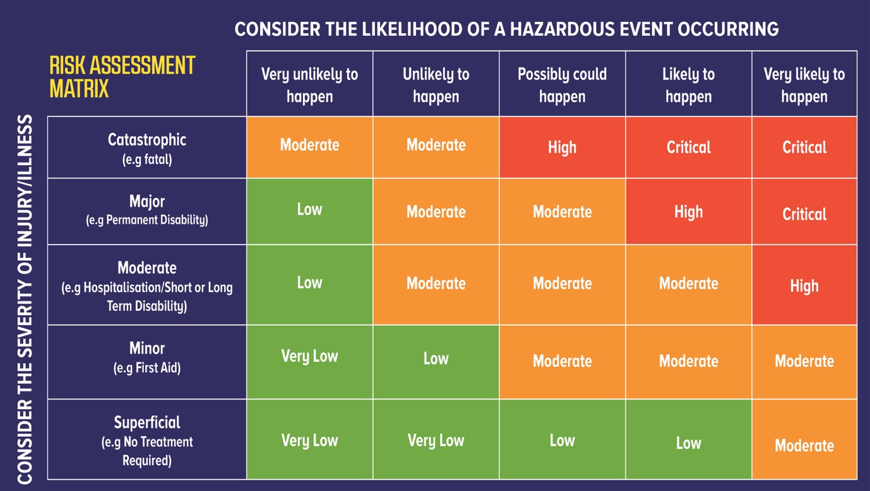

Image Source: www.sitesafe.org.nz

Using this Matrix

To properly use a Risk Assessment Matrix follow these four steps:

Step 1 – First consider the Likelihood of the hazard causing harm working from left to right, determine if this will be rare or anything else through to almost certain.

Step 2 – Next consider the Consequence of the harm by working from bottom to top, to determine how severe the harm (injury/illness) posed by the hazard would be from minimal to something that could cause death or permanent disability.

Step 3 - Follow the rows and columns to their meeting point to identify the level of risk.

Step 4 - Use the outcome (risk) to determine the risk controls and therefore the subsequent corrective and preventive actions.

Depending on the outcome of the risk, action is determined according to the severity and depending on the level of risk, the matrix helps to determine the priority for action. For example, the hazards that have the potential to cause the greatest harm are addressed first.